1. After installing WSL (see tutorials for that), install WSL extension.

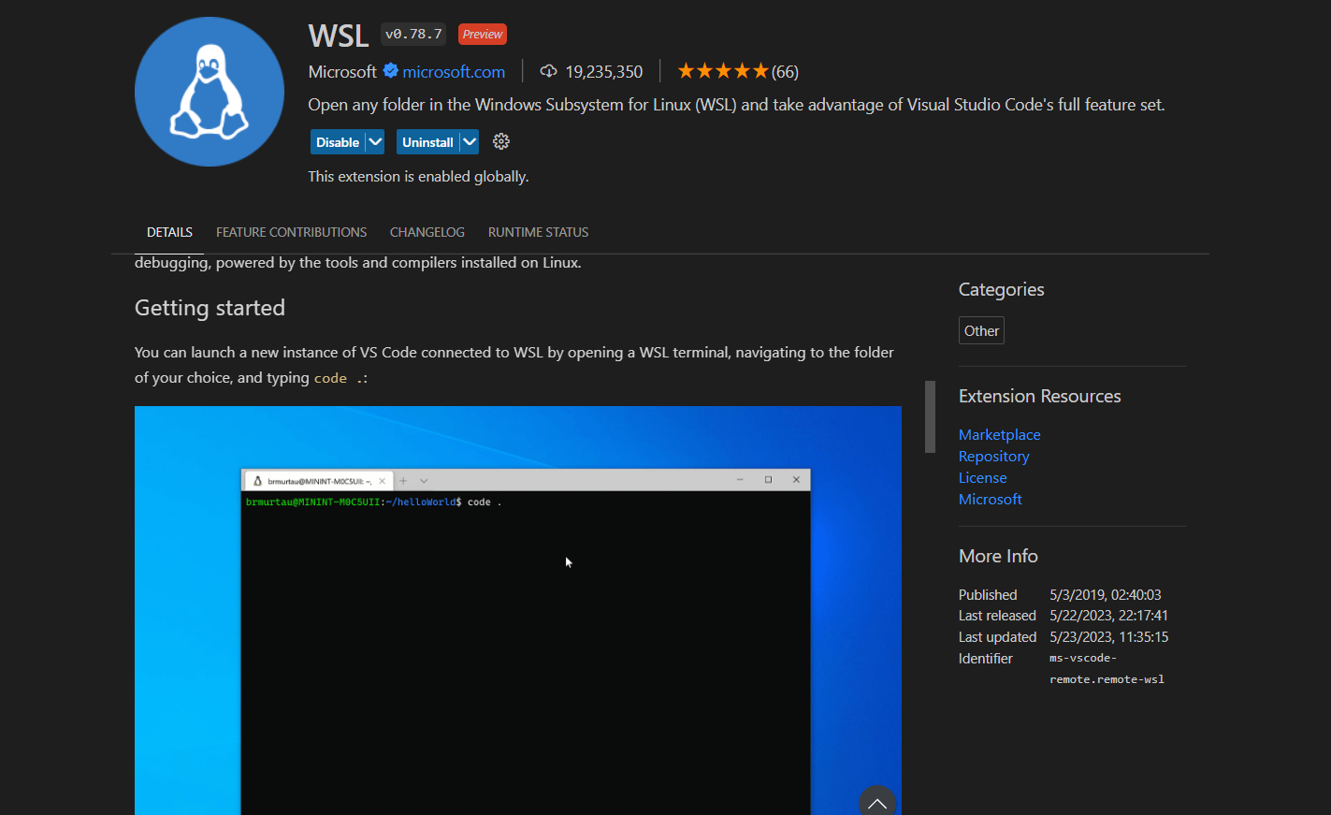

1. Then click on green button at lower left and select “connect to WSL” to start a VSCode session with WSL.
   1. Alternatively, open the folder you want to open in VSCode connected to WSL by opening your WSL terminal and navigating to it or typing “bash” in the address bar of your current folder. Then, type “code .” in the WSL terminal.

<https://learn.microsoft.com/en-us/windows/python/web-frameworks>

To activate virtual environment (note that we’re using WSL)

source <directoryname>/bin/activate



To deactivate virtual environment

Deactivate

Workflow:

* CONSIDER MAKING OR MOVING/COPYING YOUR PROJECT TO THE WSL FILESYSTEM (THE LINUX FILESYSTEM) FOR FASTER PERFORMANCE

* Source bin/activate
* code . (to run visual studio connected to WSL)
* If Django not installed yet, python3 -m pip install Django
* Install other required packages (pandas, etc)
* Install Concrete-ML for WSL (will also install scikitlearn, torch, etc. EXPECT LARGE FILE SIZES)
  + pip install -U pip wheel setuptools
  + pip install concrete-ml